Case 6-Afr-Gabon-Punu-Mask-19th century

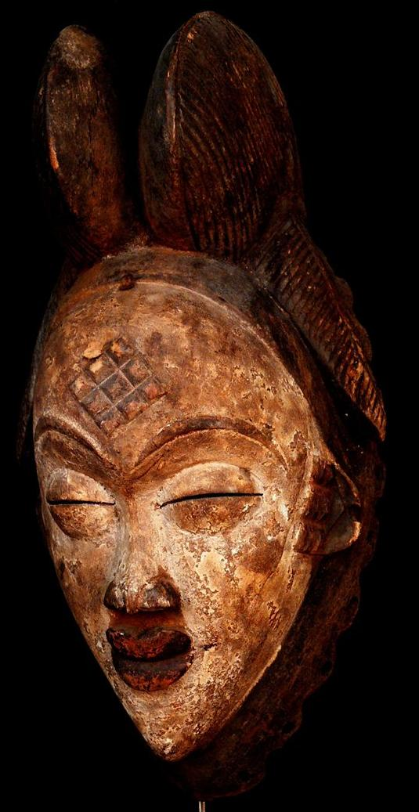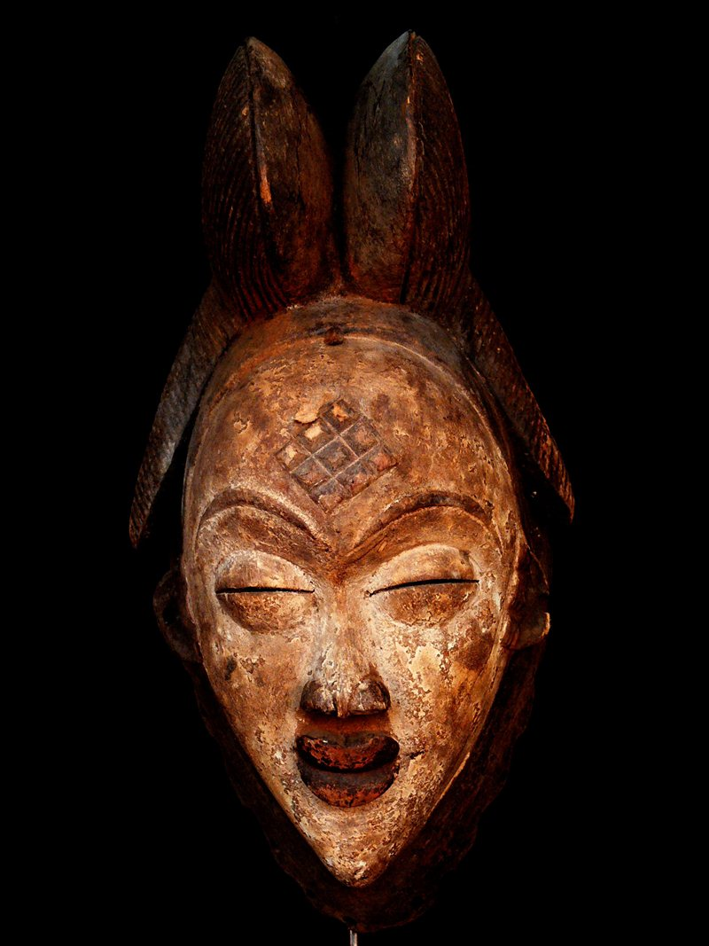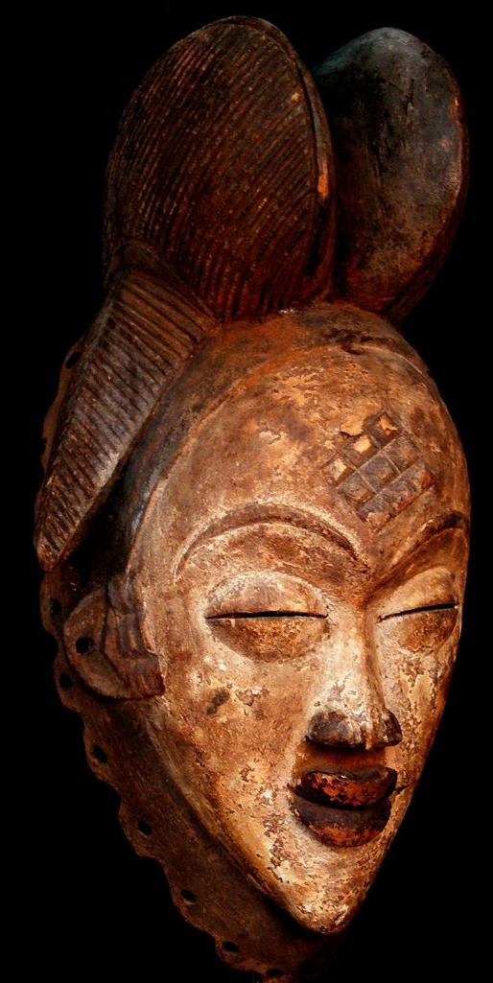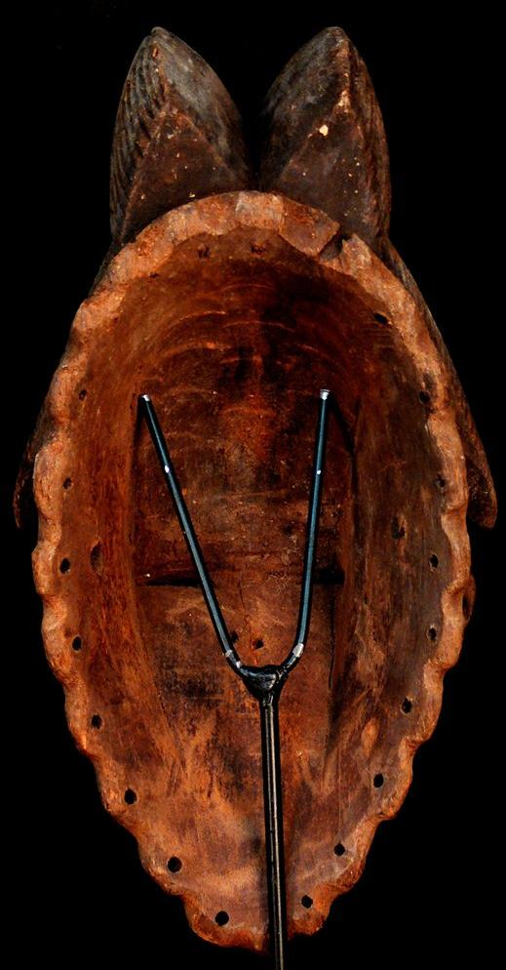

Formal Label: Gabon-Punu-Mask-19th century

Accession Number:

LC Classification: GT1748

Date or Time Horizon: 19th century

Geographical Area: Gabon

Cultural Affiliation: Punu

Medium: wood, pigments, kaolin

Dimensions: H 12.59 inchesWeight: 1.21 pounds

Provenance:

**Condition: aged**

**Discussion:**

The Punu of southern Gabon's upper Ngoumie River live in independent villages. These villages had male wood sculptors who immortalized the most revered women of the village. The surface of her idealized portrait is painted with kaolin which represents the ethereal spirit of this ancestress. The beautiful hairstyle she wears is a common feature among the Punu women, as is scarification on the forehead, a pointed nose, protruding lips, arched eyebrows narrow eyes and closed mouth. Masks such as this are used by chiefs to consult with the ancestors to divine solutions to communal problems. Numerous examples of masks of female figures commissioned by diviners are represented in western collections and all exhibit slight changes in physical features signifying they were attempts to portray real persons.

In the Punu communities of southern Gabon, *mukudj* masks are considered portraits of an exceptionally beautiful female member. The coiffure, featuring a prominent sagittal lobe flanked by two lateral tresses, is a classic style of dressing women's hair practiced throughout the region during the nineteenth century. Lozenge cicatrization markings were incised on the forehead and temples of Punu women as a form of aesthetic embellishment and a sign of sensuality. Classic *mukudj* masks often emphasize a subdivision of the motif into nine units, which is significant in light of the fact that, among the Punu, nine is considered a mystically powerful number and a catalyst in the healing process. In *mukudj* mask representations, the prominence of the number nine, as well as the red band that accentuates the hairline, make reference to the mystical powers commanded by the dancer. It is those powers that are believed to provide him with the talent and protection necessary to perform. The stylized rendering of the eyes, represented as closed slits, evokes a meditative serenity while at the same time affording the wearer an unobstructed view of the performance arena he must negotiate. The application of white kaolin to the surface of the masks is a reference to spiritual transcendence. The white kaolin clay is a sacred material linked to the parallel ancestral realm of existence and also a cosmetic associated with idealized beauty.

*Mukudj* dances are commissioned by community leaders to mark important occasions—to commemorate the memory of an important member of the community, to celebrate the return or the visit of an honored individual, or to mark a development that will enhance the community's well-being. The *mukudj* dance is performed on stilts of up to three meters in height; dancers must train from childhood to master the difficult and demanding choreography. During official celebrations, a *mukudj* dancer towers above his audience and executes acrobatic feats that demand agility, strength, and an acute sense of equilibrium. Because of the extraordinary nature of the performance, dancers are perceived as exceptional individuals who draw upon mystical powers to accomplish such a feat. The thrilling spectacle of *mukudj* performances alternates between passages of lyrical grace and explosive power.

*Mukudj* performances are appreciated as the most aesthetically appealing and exciting form of expression in Punu culture and consequently have become a national icon of Gabon. *Mukudj* masks are displayed as proud insignia of Punu cultural identity in domestic contexts in the capital, Libreville, as well as in rural villages of the remote interior.

*Mukudj* masks are now used to entertain audiences during festivals or celebrations. On rare occasions *Mukudj* masks are used during divinations. During these rituals masqueraders dance, and they embody the spirits of male and female ancestors in hopes of eliciting the proper action by which to proceed in resolving a communal issue.

**References:**

Perrois, Louis and Charlotte Grand-Dufay. 2008. *Punu*. Tr. Isabel Ollivier. Milan: 5 Continents.